AI Based Plant Disease Recognition and Classification for Precision Agriculture using Image Segmentation and Augmentation

*Saurabh Mishraa, Shakti Maddeshiyab, Shivanshu Singhc aDepartment of Computer Science, KIET Group of Institution, Ghaziabad bDepartment of Computer Science, KIET Group of Institution, Ghaziabad cDepartment of Computer Science, KIET Group of Institution, Ghaziabad*

## **Keywords**: Deep Learning, Convolutional neural network, Image Segmentation, Image Augmentation

**ABSTRACT**

The world's population depends heavily on agriculture, but agricultural production is still seriously threatened by plant diseases. Manually tracking plant diseases takes time and is prone to error. Early plant disease detection is possible with the use of computer_vision and artificial intelligence (AI), which can help to mitigate their negative consequences and overcome the limitations of ongoing human surveillance. This article presents an automated technique that uses an idea of convolutional neural_network model to detect and classify plant leaf diseases. Deep learning convolutional neural networks are like powerful tools for spotting plant diseases. We can solve this problem by cutting out only the important parts from the pictures (we call them regions of interest or ROIs) before giving them to the CNN. This can make the model work much better. Regarding data augmentation methods, we discovered that the CNN architectures perform noticeably better when the rotation, shift, and zoom techniques are combined. Furthermore, integrating data augmentation methods with the offline training approach yields the most accurate outcome. Plant leaf disease detection could be transformed by DL. Deep learning (DL) can assist farmers in early and efficient plant disease identification and treatment, preserving crops and minimizing financial losses, by creating more resilient models that can function well on real-world imagery and early detection data.

# INTRODUCTION

Our world is undergoing a rapid transformation, with far-reaching impacts on economic, social, and ecological activities. These changes have had a profound effect on agriculture, one of the cornerstones of human civilization. Global population increases by approximately 1.6% each year and the demand for agricultural products is surging. Feeding this expanding populace presents a formidable challenge, especially when considering the need for both quantity and quality in agricultural yields. A pivotal factor in meeting this demand while ensuring crop sustainability is the effective protection of plants against diseases. Plant diseases not only threaten food security but also carry substantial economic consequences. India stands as

an example of the significant impact of plant diseases. The Indian Council of Agricultural Research reports that pests and diseases annually reduce agricultural output by an alarming percentage, underlining the detrimental effects these issues can have on food production. To detect and treat crop illnesses, farmers have historically relied on a patchwork of resources, ranging from tips from other farmers to national hotlines like the Kisan helpline. But this method is frequently inaccurate, time-consuming, and might not be accessible to everyone. The requirement for laboratory sets to prove the existence of plant diseases in specific circumstances highlights the limitations of standard disease detection approaches. For many farmers, especially those in resource-poor areas, inadequate infrastructure and the lack of professional advice are

harsh realities. Although beneficial, seeking professional advice can be extremely costly and time-consuming, which increases the difficulties encountered by rural areas.

In traditional plant disease identification, a process is followed i.e., K-means clustering to find and isolate the areas with lesions on the plants. Then, they collected information about the colours and textures in those regions using methods like global colour histogram, colour_coherence vector, local binary_pattern and completed local binary pattern. After gathering this information, they used a machine learning approach called Support_Vector Machine, but with some improvements. This system was able to identify plant diseases with an accuracy of 93%. In short, it can be concluded that studies on plant disease recognition based on traditional image processing technology has made significant progress and can now identify diseases with high accuracy, there are still flaws and restrictions.

A deep learning model was trained by Mohanty et al. to identify 26 crop diseases and 14 crop species. The trained model attained an accuracy of_99.35% on the test set by performing symptom-wise recognition of four cucumber diseases_ (downy mildew, anthracnose, powdery_mildew, and target leaf spots) using a deep CNN. The accuracy of recognition was 93.4%. A CNN-based system for identifying cucumber leaf disease was introduced by Kawasaki et al. and achieved 94.9% accuracy.

The diversity of the datasets used is limited, despite the fact that very positive results have been reported in the literature. CNNs must be trained on sizable datasets, each containing thousands of images. Regrettably, such vast and varied datasets have not yet been gathered for plant leaf disease detection. Currently, the best method for training CNN classifiers' robustness in identifying plant leaf diseases is transfer learning. Transfer learning allows the network to be adapted by retraining pre-trained CNNs using smaller datasets whose distribution is different from the larger datasets used to train the network from scratch. In fact, retraining CNN models for leaf disease detection after they have already been trained on the ImageNet dataset proves to be an effective method. Consequently, combining deep learning and transfer learning presents a fresh approach to address the problem of limited plant disease datasets.**LITERATURE REVIEW**

The author of this study report talked about how plant diseases are becoming more common every day and how delayed diagnosis and treatment negatively impacts crop productivity overall. Plant sicknesses can make plants produce less, but if we watch them carefully, we can stop this from happening. Checking plants for sickness by looking at them closely takes a lot of time and can lead to errors. But if we use artificial intelligence (AI) and sensors to look at the plants, we can find out plant disease in earlier stages. Which can assist to mitigate their negative consequences and overcome the limitations of ongoing human surveillance. For this work, they suggested classifying tomato plant illnesses using 18,161 plain and segmented tomato leaf images and a convolutional neural network-based deep learning architecture known as EfficientNet. [1]

The primary topic of this research study is the use of mobileNet based CNN for automated plant disease detection and categorization. Since agriculture is the primary industry in India, plant diseases cause an estimated 35% of agricultural output losses each year. Early plant disease detection is a laborious procedure due to inadequate laboratory infrastructure and specialized knowledge. The tedious work of keeping an eye on vast crop farms may be reduced by using automated plant disease detection tools, which can also detect disease signs when they first appear on plant leaves. In this literature, they introduced the OMNCNN model, which acts on four distinct stages: preprocessing, segmentation, feature extraction, and classification.[2]

This research study discusses disease forecasts primarily relevant to tomato plants. The tomato plant is susceptible to a number of serious illnesses, powdery mildew being one of them that is mostly covered in this literature. as the tomato plant's powdery mildew disease, which in turn slows down the development of tomato fruit. Therefore, to lessen the financial losses brought on by the illness, powdery mildew must be detected accurately and promptly. The final goal of this research study is to create a hybrid algorithm that predicts tomato plant powdery mildew illness by combining the strengths of logistic regression (LR) and support vector machines (SVM). The prediction models have also been developed using the SVM and LR algorithms separately. According to the results, the suggested classifier outperforms SVM by 3.06% and 5.35%. better than LR with an accuracy of 92.37%.[3]

This study paper's major subject is about how most plant diseases have visible signs, and the currently recognized method involves having an experienced plant pathologist visually inspect diseased plant leaves to identify the illness. The fact that the disease diagnosis procedure is laborious to complete by hand and that the outcome of the diagnosis depends on the pathologist's skill level make this an ideal challenge for computerized diagnostic systems. This study suggests classifying plant leaf diseases using the EfficientNet deep learning architecture. The test dataset showed that the B4 and B5 models of the EfficientNet architecture achieved the highest values and exceeded other deep learning models in both the original and upgraded datasets. approximately 99.91% and 99.97% for precision and 98.42% and 99.39% for accuracy, respectively.[4]

Scholars have investigated a range of deep learning architectures, whether created or modified, to take advantage of their potential when combined with visualization methods to efficiently detect and classify plant disease signs. To determine how well these designs perform in disease recognition tasks, a variety of performance indicators are used for evaluation. The combination of deep learning methodologies and visualization approaches signifies a substantial advancement in the precise and effective detection and categorization of plant diseases, with ample prospects for enhancing farming procedures and crop management. [5]

India is among the many nations whose main source of national wealth is agriculture. Plant and agricultural diseases are the main factors that reduce production quantity and quality, which hurts the economy. Therefore, it is critical to identify plant diseases. Plant disease symptoms might be seen in many plant components. Plant leaves remain the most often used means of diagnosing the illness. Researchers utilize soft computing and computer vision techniques to identify plant illnesses from images of leaves. The components of such study are outlined in this paper, along with their advantages and disadvantages. Common ailments and the state of research at different stages of such detection systems are analyzed. We review the state-of-the-art feature extraction techniques and identify those that appear to cover a broad spectrum of crop kinds. The research would help that the investigators understand how relevant computer vision is to plants. [6]

Deep neural networks have demonstrated remarkable efficacy in solving picture classification tasks. In this study, we demonstrate the application of neural networks to picture classification for the identification of plant diseases. We utilized the 38 illness classifications in the publicly accessible Plant Village The focus of our investigation centers on multiclass categorization. To establish the groundwork for our study, we scrutinized five distinct architectures: ResNet50, InceptionV3, DenseNet169, VGG16 and InceptionResNet. Upon evaluation, it was discerned that ResNet50 outperformed the others on the test set. Our assessment utilized various metrics including recall, accuracy, precision, F1 score, and class-wise confusion meter. Notably, ResNet50 exhibited the most favorable outcomes for our model, achieving an accuracy of 0.985, precision of 0.96, recall of 0.98, and F1 score of 0.96. [7]

A novel approach utilizing state-of-the-art computer vision techniques has been proposed to develop a deep learning-based model for multi-class plant disease identification While the majority of earlier models were limited to large-scale disease detection, the new model aims to reliably identify fine-grained, multi-scale early sickness detection. The proposed model has been optimized for both speed and accuracy of detection, and it has been applied to the real-world detection of several types of apple plant diseases. The detection model's F1-score and mean average accuracy rose to 94.87% and 90.89%, respectively, at 55.6 frames per second. The entire detection result indicates that the current technique performs much better than the state-of-the-art detection model, with an improvement of 7.54% in F1-score and 9.24% in accuracy. In complicated orchard situations, the suggested approach may be used as an efficient and successful way to identify various illnesses affecting apple plants. [8]

The majority of plant damage is caused by plant diseases, hence decision-makers in the agriculture sector have a stake in developing prediction strategies for early plant disease detection. This will enable correct plant care to be provided at the right time. Algorithms for classification and clustering have shown promise in the early diagnosis of plant diseases. Creating groups of plants with related characteristics is a great way to examine traits and give a general idea of the standard of care given to related plants. In order to improve plant disease prediction strategies by combining both k-means and kmedoids, we present an artificial intelligence (AI) model in this study that blends k-means with k-medoids.By integrating both k-means and k-medoids algorithms, the model utilizes the strengths of both approaches. The k-NN classifier and k-efficient clustering form the foundation of the model. The purpose of this article is to evaluate the performance of k-mean, k-medoids, and k-efficient. We also evaluate k-NN before to and after clustering in soybean disease prediction to find out which is more effective for forecasting plant diseases. These objectives enable us to examine plant data that advances our knowledge of the nature of plants. The results demonstrate that k-NN with k-efficient outperforms other in terms of recall, accuracy, precision, running time, F-measure, normal mutual information (NMI), and dynamics across and within classes. [9]

Changes in host resistance, host-pathogen interaction physiology, and pathogen stages and rates of development might all be brought about by climate change. The most likely effects are changing crop losses and changes in the geographic spread of the disease and host, partly due to variations in the effectiveness of management measures. There is a great deal of hope in the recent advances in modeling and experimental approaches for strengthening our capacity to evaluate and reduce the consequences of climate change. Even though it may not have as much of an impact on agricultural production as other major technological, environmental, and socioeconomic developments over the course of the next century, climate change will still add another degree of complexity and uncertainty to a system that is already extremely difficult to manage in a sustainable way. Increased investigation into topics relating to climate change may lead to a better understanding.[10]

# Materials and method

Precision agriculture plays a crucial role in maximizing crop yield and minimizing resource usage. In this context, the proposed research aims to develop an advanced computer vision-based system in order to identify and categorize plant diseases, specifically targeting maize plants. The methodology integrates image segmentation and augmentation techniques with convolutional neural networks (CNN) to improve both the precision and effectiveness of disease diagnosis.

### Dataset Description

In this study, the accuracy of the deep learning approach was experimented on datasets of plant leaf diseases, consisting of images of diseased and healthy plants’ leaves. We have obtained a dataset from Kaggle that includes three different classes of potato leaves, one of which is early blight, the subject of our current investigation.

In essence, Alternaria solani is the fungus that causes early blight. Although it primarily affects potatoes, it can also infect other solanaceous crops like tomatoes, eggplants, and peppers. It is a prevalent and widespread disease. Ailments The older, lower leaves of the plant are usually the first to show signs of early blight. On the leaves, tiny, dark brown dots may appear and then grow to form concentric rings, giving the spots a "target board" appearance. The first symptoms of late blight typically appear on the lower leaves of the plant. Small, water-soaked spots develop on the leaves, which quickly turn brown to black. The spots may enlarge and merge together, covering the entire leaf. In humid conditions, a white fungal growth may be seen on the underside of the leaves.

Late Blight (Phytophthora infestans): Causal Agent: Late blight is caused by the oomycete (water mold) pathogen Phytophthora infestans. Symptoms: Initially, dark lesions appear on leaves, typically with a water-soaked appearance. These lesions can rapidly enlarge and become surrounded by a yellow halo, giving the affected foliage a burned appearance. White fungal growth (sporulation) may be visible on the underside of the leaves, especially in humid conditions. The disease can also affect stems and tubers, causing rotting. favourable Conditions: Late blight thrives in cool and moist conditions. It spreads rapidly during periods of high humidity and moderate temperatures. Management: Control measures include the use of resistant potato varieties, fungicides, crop rotation, and proper sanitation practices. Early Blight (Alternaria solani): Causal Agent: Early blight is caused by the fungus Alternaria solani. Symptoms: Early blight symptoms start as small, dark spots with concentric rings on lower leaves. Lesions can enlarge and coalesce, leading to the development of large, irregularly shaped spots with a target-like appearance. Affected leaves may yellow, wither, and eventually die. Favourable Conditions: Warm and humid weather favours the development of early blight, but the disease can occur in a range of environmental conditions. Management: Strategies for managing early blight include using resistant potato varieties, applying fungicides, practicing crop rotation, and maintaining good garden hygiene. Both diseases can lead to significant yield losses if not effectively managed. Crop rotation, planting resistant varieties, and timely application of fungicides are crucial components of integrated disease management strategies. Additionally, monitoring environmental conditions and adopting good agricultural practices can help minimize the impact of late blight and early blight on potato crops.

Symptoms: Lesions on Leaves: Dark, water-soaked lesions initially appear on the leaves, often near the tips and edges. Lesions can rapidly expand, and affected foliage takes on a brown to black colour. Halo Effect: Lesions are typically surrounded by a yellow halo, giving the affected areas a distinctive appearance. Spore Production: White, fuzzy growth (sporulation) may be visible on the underside of leaves during periods of high humidity. Stem and Tuber Infection: Stems can also be infected, leading

to a darkening and decay of the affected areas. Tubers may develop rot, making them unmarketable. Favourable Conditions: Late blight thrives in cool and moist conditions. It is particularly problematic when temperatures range from 50 to 80 degrees Fahrenheit (10 to 27 degrees Celsius) and humidity is high. Rainy and foggy weather can contribute to the rapid spread of the disease.

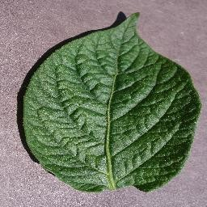(1) 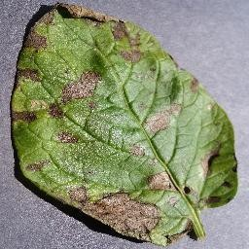(2) 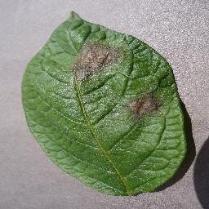(3)

**Figure 1.** Example of leaf images from the PlantVillage dataset.

(1) Potato_Healthy, (2) Potato_EarlyBlight, (3) Potato_LateBlight.

### Methodology

The block diagram of a suggested method for identifying potato leaf disease is shown in Figure 2. The system's phases are (i) Gathering datasets (ii) Enhancing data (iii) Segmenting Data (iv) Model Development (v) Training and Validation (vi) Classification using CNN

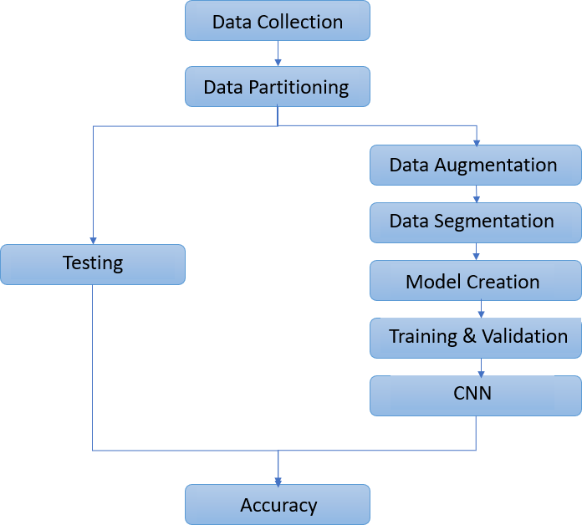

**Figure 2.** Block Diagram

Our CNN model was able to detect disease in potato plants with an accuracy of over 98%. Following the reading of the pictures, random regions of 256 by 256 pixels are selected, and noise, distortion, flip, and rotation transformations are performed. Controlling the stride lengths, mask size, using several convolution and pooling processes, and enhancing the quality of the data applied to the pictures increase the likelihood of extracting relevant features. Very helpful libraries with several techniques to aid in the process of data augmentation are provided by Tensorflow and Keras. By producing changed reproductions of the original photographs, this aids in increasing the size of the dataset. This change will enable the model to perform better and generalize what it has learnt. Applying a mask to each pixel and selecting a single value from the mask are the steps involved in pooling. Many pooling stages are involved in the mixing process. Three approaches have been put into practice: RandomFlip, RandomRotation and a combination of the first two—RandomRotation and ResizedCrop function—which causes the pictures to be rotated by 30 degrees to the left or right. The image undergoes a process called RandomResizedCrop, where it's randomly cropped to a size ranging between 8% and 100% of its original size. During the training phase, the model may be taught to learn the decision boundaries required to classify photographs into multiple Groups by using a Rectified Linear Unit (ReLU) and random dropouts. The size of the outputs and filters varies as the input moves through the system, enabling training for and detection of comparable characteristics with various scaling. Because convolution filters are applied to the whole picture for training data, CNNs are resistant to feature modifications like translation and rotation. The model is implemented using Python and TensorFlow. Since it accepts unnormalized log probabilities as inputs and outputs the probability distribution over the target classes, the softmax function is the last stage of operation in a network. This activation function is utilized for multiclass classification, since our system distinguishes between two types of potato leaf disease and healthy leaves. Thus, it is advantageous to use it in a logistic regression model. The logits layer, which is also referred to as the neural network's final neuron layer for classification, produces raw data in the form of real numbers. These three classes in our model have their corresponding logits values from the logits layer. The softmax function must be used to compute probabilities in order to determine the suitable class. For each result, a discrete probability distribution function is utilized. By taking the exponents of each output and normalizing each output number by the total of this exponent value, it converts the numerical real value logits into probabilities. The exponential function interprets non-positive numbers as positive, and probability values are taken between zero and one.

### Architecture

Convolutional neural networks feature regularized multilayer perception and are classified as deep neural network models. It is better than hierarchical patterns and makes it easier to solve complex patterns using fundamental patterns. Its uses are numerous and include natural language recognition, recommendation systems, and picture categorization. A typical CNN model has many layers and uses differentiable functions to convert one activation volume to another. As seen in Figure 1, the convolution, pooling, and fully linked layers are the main components of a CNN model. The convolution layer is the primary component of CNN. It primarily uses dot operations to establish a connection between the kernel and the restricted region. The CNN model's Pooling layer is the next crucial layer. The Pooling layer's main advantage is that it uses fewer weights, which reduces computation and spatial size. In order to introduce nonlinearity into the convolution process which is normally linear and occurs immediately after the convolution layer.

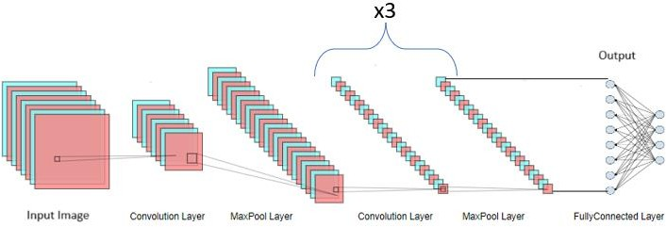

**Figure 3.** CNN Architecture with convolutional, pooling, and fully connected layers

# Result and Discussion

This section examines at the proposed model's performance in identifying plant diseases using a benchmark dataset of potato plant leaves. The experimental findings are examined using several measures.

Every experimental study used both the augmented and original datasets. Figure 3 displays the accuracy and confidence values the model achieved on the test data for both the datasets.

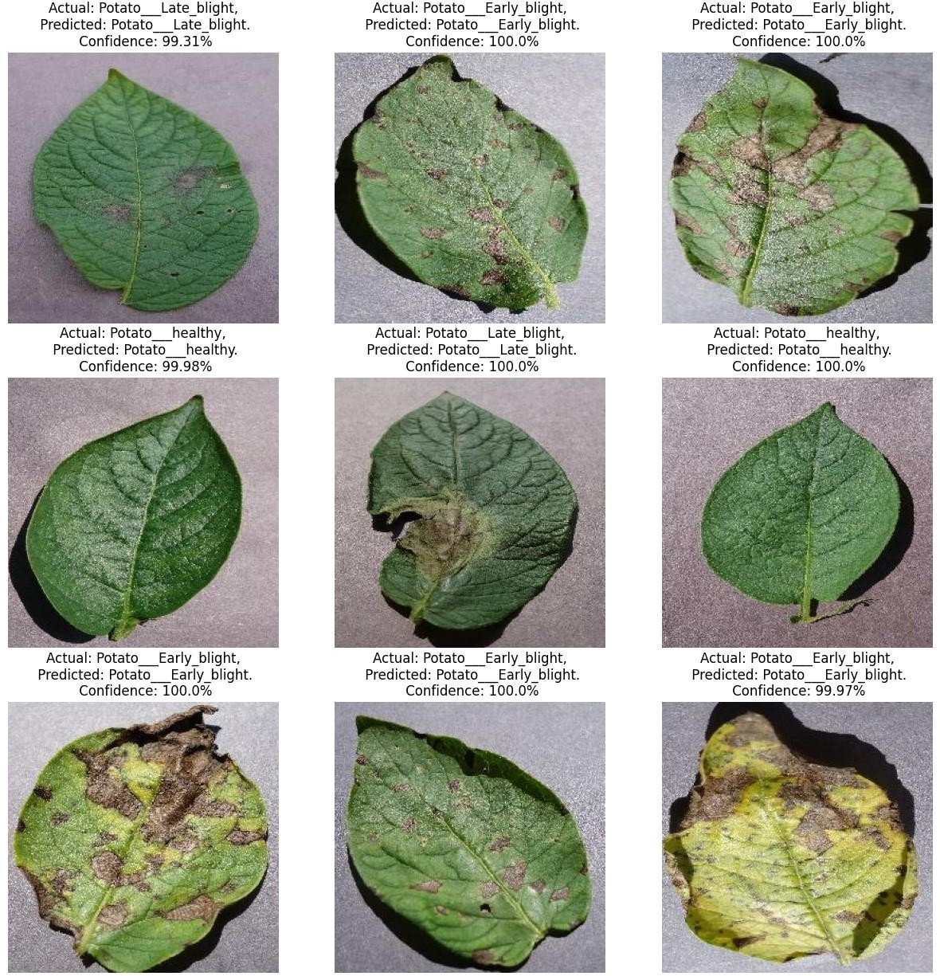

**Figure 4.** Sample visualization results of the model

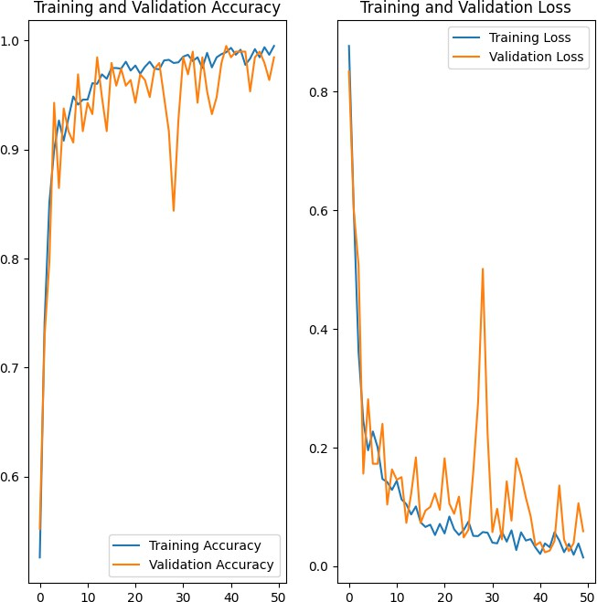



We combined the original training images with the augmented ones to produce a new training dataset once we had enough augmented data, and we utilized the same test dataset to evaluate the newly trained model's performance. The experimental findings demonstrate that the retrained model achieves a better performance with accuracy of 98.44% after utilizing the new training dataset to retrain the model with epochs = 50.

# CONCLUSION

In conclusion, our research efforts in the field of AI- based plant disease recognition and classification for precision agriculture have shown encouraging outcomes, which represents a major advancement in filling the gaps in the current plant disease detection approaches that are mechanized or computerized. Even with a variety of approaches, there are still no complete solutions or commercial applications in the field of automated plant species detection, especially when it comes to leaf image-based methods.

This article presents a novel method for automatically classifying and identifying plant diseases from leaf images by utilizing convolutional neural networks (CNN), a deep learning technology. The created model performed admirably in identifying whether leaves were there and differentiating between leaves that were healthy and leaves that were affected by one of the 2 diseases that were found; each ailment may be visually

Additionally, we achieved good accuracy in every class. The results of the experiment indicate that deep learning models combined with deep transfer learning strategies are effective options for determining the severity of plant diseases. Moreover, a significant factor affecting Deep Learning's performance is the training epoch size. It depends on both the kind of model and the amount of the dataset.

inspected. The whole process has been thoroughly documented, starting with the painstaking gathering of training and validation images and continuing through the complex phases of image preprocessing, augmentation, and deep neural network training. Extensive experiments and testing have been carried out to assess our model's performance and provide us an understanding of its strengths and weaknesses.

Notably, when the present model is used, it produces a binary output that categorizes leaves as either healthy or unhealthy. Still, there's a lot of room for improvement and growth. By utilizing more advanced neural network architectures and incorporating a wider range of diverse and large- scale datasets, the Disease Detection System could potentially achieve higher accuracy and identify a wider range of plant diseases.

### REFERENCES

1. Chowdhury, M.E.; Khandakar, A.; Ahmed, S.; Al-Khuzaei, F.; Hamdalla, J.; Haque, F.; Mamun, B.I.R.; Ahmed, A.S.; Nasser, A.E. Design, construction and testing of iot based automated indoor vertical hydroponics farming test-bed in Qatar. Sensors 2020, 20,5637
2. R.N. Strange, P.R. Scott, Plant disease: a threat to global food security, Annu. Rev. Phytopathol. 43 (2005) (2005) 83–116.
3. W. B. Jones, S. V Thomson, and others, “Source of inoculum, yield, and quality of tomato as affected by Leveillula taurica.,” Plant Dis., vol. 71, no. 3, pp. 266– 268, 1987.
4. KC, K., Yin, Z., Wu, M., Wu, Z., 2019. Depthwise separable convolution architectures for plant disease classification. Comput. Electron. Agric. 165, 104948.
5. McCulloch, W.S.; Pitts, W. A logical calculus of the ideas immanent in nervous activity. Bull. Math. Biophys.1943, 5, 115–133.
6. Abdulridha, J., Ampatzidis, Y., Ehsani, R., & de Castro, A. (2018). Computers and Electronics in Agriculture, 155, 203–211.
7. Sagar, Abhinav & Jacob, Dheeba. (2020). On Using Transfer Learning For Plant Disease Detection. 10.13140/RG.2.2.12224.15360/1.
8. Tyagi, A.C. Towards a second green revolution. Irrig. Drain. 2016, 65, 388– 389.
9. A. M. Abdu, M. M. M. Mokji, and U. U. U. Sheikh, “Machine learning for plant disease detection: an investigative comparison between support vector machine and deep learning,” IAES Int. J. Artif. Intell., vol. 9, no. 4, pp. 670–683, Dec. 2020, doi: 10.11591.
10. Coakley SM, Scherm H, Chakraborty S. Climate change and plant disease management. Annu Rev Phytopathol. 1999 Sep; 37:399-426. doi: 10.1146/annurev.phyto.37.1.399. PMID: 11701829.
11. Hossain, S.; Lee, D.-J. Autonomous-Driving Vehicle Learning Environments using Unity Real-time Engine and End-to-End CNN Approach. J. Korea Robot. Soc. 2019, 14, 122–130.
12. Koci´c, J.; Joviˇci´c, N.; Drndarevi´c, V. An End-to-End Deep Neural Network for Autonomous Driving Designedfor Embedded Automotive Platforms. Sensors 2019, 19, 2064.
13. Esteva, A.; Robicquet, A.; Ramsundar, B.;

Kuleshov, V.; DePristo, M.; Chou, K.; Cui, C.; Corrado, G.; Thrun, S.;Dean, J. A guide to deep learning in healthcare. Nat. Med. 2019, 25, 24.

1. Miotto, R.; Wang, F.; Wang, S.; Jiang, X.; Dudley, J.T. Deep learning for healthcare: Review, opportunities and challenges. Brief. Bioinform. 2017, 19, 1236–1246.
2. Ravì, D.;Wong, C.; Deligianni, F.; Berthelot, M.; Andreu-Perez, J.; Lo, B.; Yang, G.-Z. Deep learning for health informatics. IEEE J. Biomed. Health Inform. 2016, 21, 4–21.
3. Goodfellow, I.J.; Bulatov, Y.; Ibarz, J.; Arnoud, S.; Shet, V. Multi-digit number recognition from street view imagery using deep convolutional neural networks. arXiv 2013, arXiv:1312.6082.
4. Jaderberg, M.; Simonyan, K.; Vedaldi, A.; Zisserman, A. Deep structured output learning for unconstrained text recognition. arXiv 2014, arXiv:1412.5903.
5. Yousfi, S.; Berrani, S.-A.; Garcia, C. Deep learning and recurrent connectionist-based approaches for Arabic text recognition in videos. In Proceedings of the 2015 13th International Conference on Document Analysis and Recognition (ICDAR), Tunis, Tunisia, 23–26 August 2015; pp. 1026–1030.
6. DeVries, P.M.; Viégas, F.;Wattenberg, M.; Meade, B.J. Deep learning of aftershock patterns following large earthquakes. Nature 2018, 560, 632.
7. Mousavi, S.M.; Zhu, W.; Sheng, Y.; Beroza, G.C. CRED: A deep residual network of convolutional and recurrent units for earthquake signal detection. Sci. Rep. 2019, 9, 10267. opportunities and challenges. Brief. Bioinform. 2017, 19, 1236–124.